<https://www.dailysmarty.com/posts/steps-for-deploying-a-static-html-site-with-docker-and-nginx>

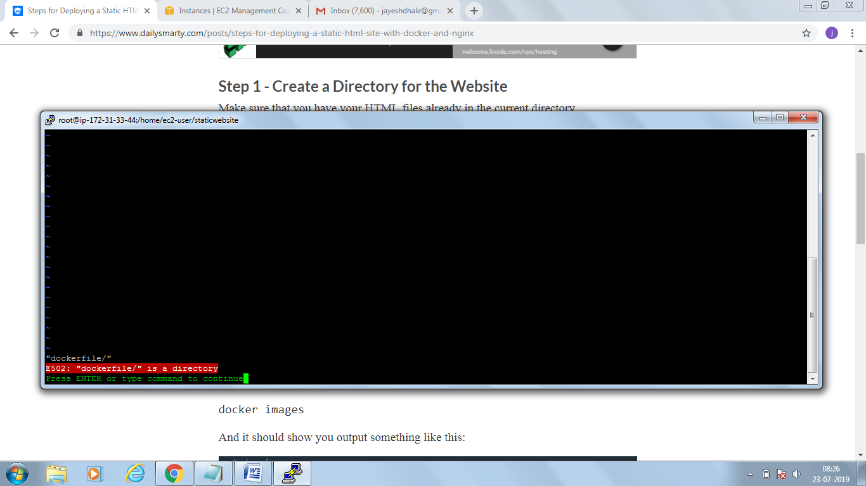

117 docker login

118 ls

119 cd dockerfile/

120 ls

121 vi dockerfile

122 docker images

123 docker build -t html-server-image:v1 .

124 docker images

125 docker run -d -p 80:80 html-server-image:v1

126 curl localhost:80

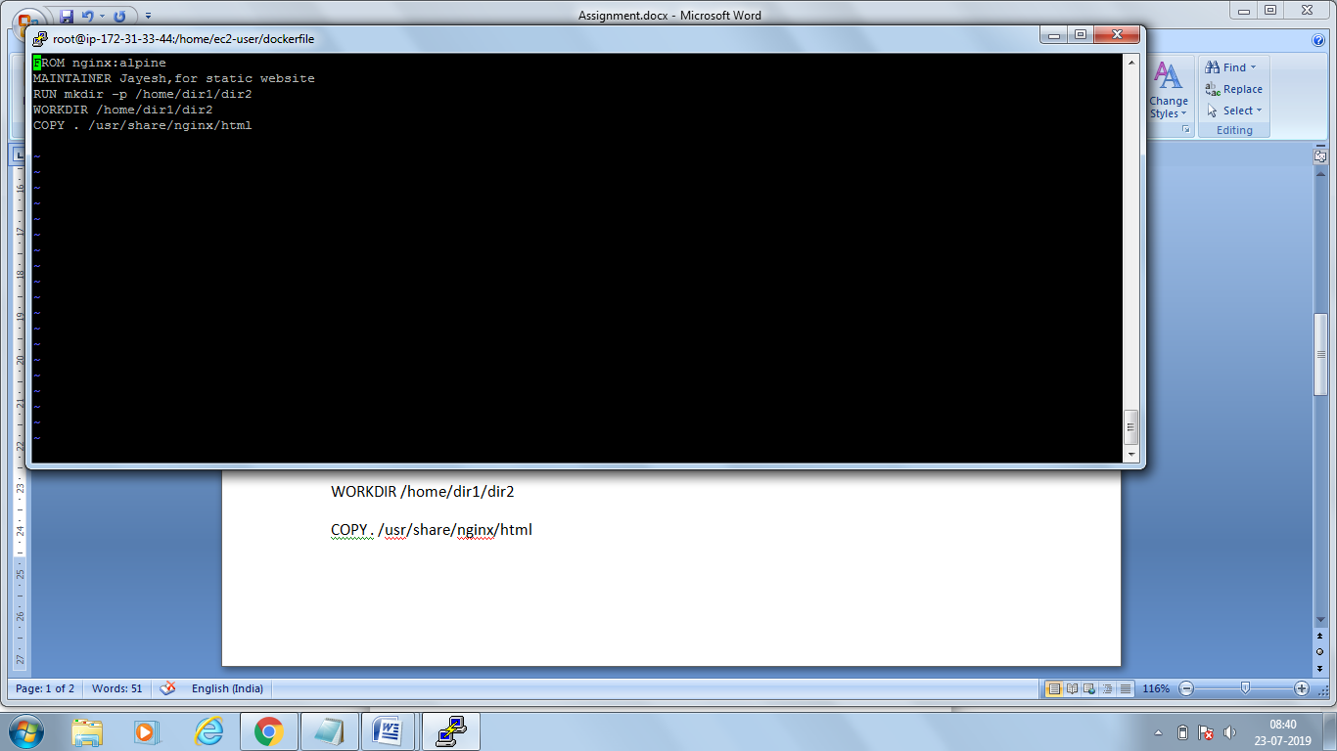

FROM nginx:alpine

MAINTAINER Jayesh,for static website

RUN mkdir -p /home/dir1/dir2

WORKDIR /home/dir1/dir2

COPY . /usr/share/nginx/html

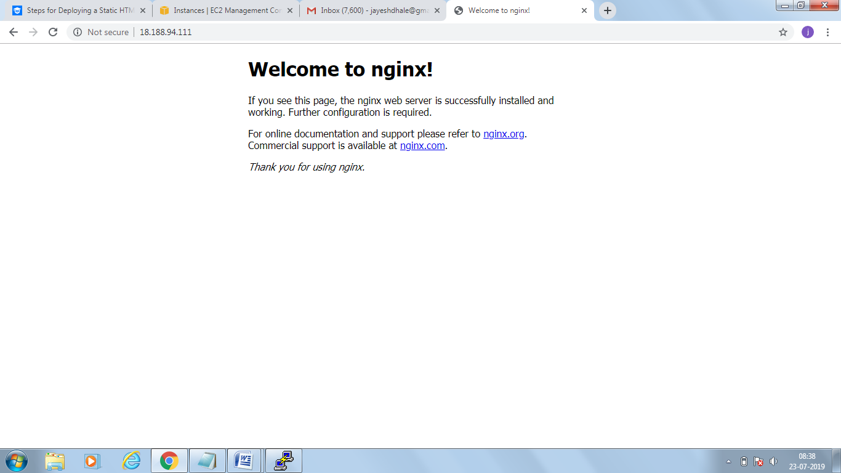

**Assignment2: Deploy artifact**

mkdir assignment2

cd assignment2

Download artifact from Jenkins dashboard

**Syntax:**

wget --auth-no-challenge --http-user=<jenkinsuser> --http-password=<jenkinspassword> http://<Jenkins Public IP>:8080/job/ci-job/4/artifact/webapp/target/webapp.war

**Example:**

wget --auth-no-challenge --http-user=admin --http-password=admin <http://18.1.1.1:8080/job/ci-job/4/artifact/webapp/target/webapp.war>

=============== copy artifact address ===========

Go to job and copy links

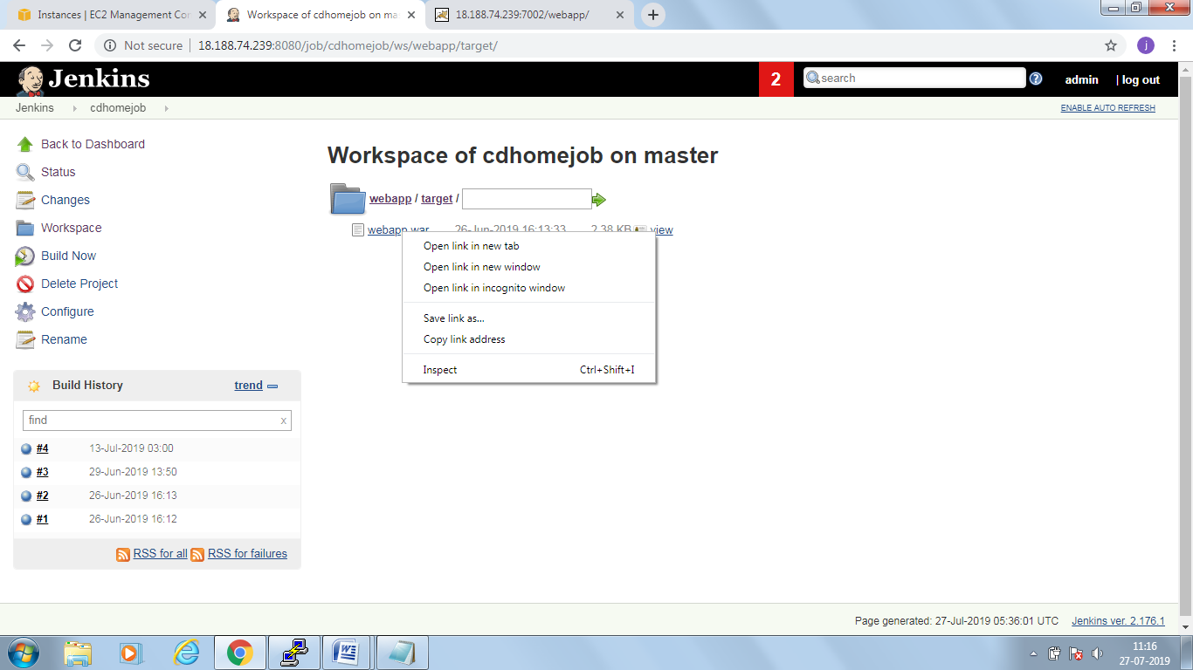

docker login

133 cd assignment2

134 ls

135 cd

136 cd -

137 wget --auth-no-challenge --http-user=admin --http-password=admin http://18.188.74.239:8080/job/cdhomejob/ws/webapp/target/webapp.war

138 ls

139 vi Dockerfile

142 docker build -t tomcat1 .

143 docker run -itd --name mytomcat1 -p 7002:8080 tomcat1

vi Dockerfile

FROM tomcat

MAINTAINER Prakash

COPY webapp.war /usr/local/tomcat/webapps

------------------------------------------------

docker build -t tomcat1 .

docker run -itd --name mytomcat1 -p 7002:8080 tomcat1

<VM IP>:7002/webapp

===========================================================

**Out put**

